App Attack Documentation Starlight Website

What you need to have installed:

* Node Js and NPM <https://nodejs.org/en/download/>

How to install Node Js and NPM follow the link to the download above, then hit next

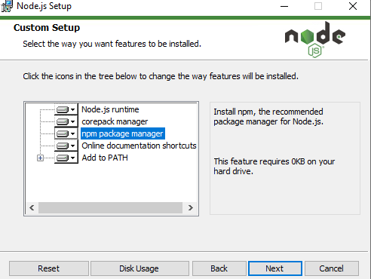

Make sure you have NPM highlighted and then hit next.

Then hit next continuously till you finish installing.

Now you need to clone the repository for App Attack (make sure it’s the documentation branch)

<https://github.com/Hardhat-Enterprises/AppAttack/tree/documentation>

To start running the website type into a terminal in vscode or cmd etc. put in this command ‘npm run dev’

If you get an error saying astro is not recognised run the command ‘npm install’

You should then be able to open the website <http://localhost:4321/>